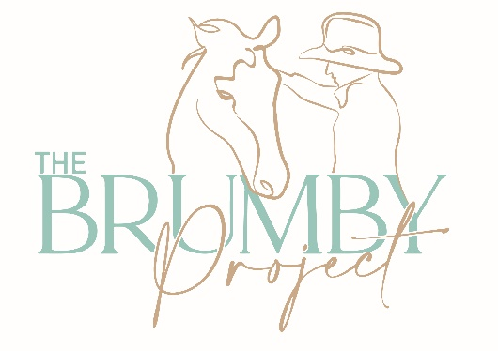

**Booking form for 2025 Amamoor 10 Day Brumby Camp**

|  |  |
| --- | --- |
| **Participant Details** | |
| *First name / Name* |  |
| *Address/where are you travelling from (please include State).* |  |
| *Email address and mobile phone number* |  |
| *Emergency Contact details/ next of kin* |  |
| *Medical History/important medical details*  *(allergies/medications)* |  |
| *Dietary Requirements* |  |
| *Rider Level*  *Please detail your horse experience/aims for this camp.* |  |
| *Do you plan on taking a brumby home?* |  |
| *Do you have any special requirements/requests for this camp?* |  |
| *What is your camping setup? Approximate size (ie swag or large truck) Will you require access to power/water?* |  |
| *Long sleeve workshirt – please indicate the size and colour you require. Included in your program cost, $89 for additional shirt.* |  |
| *Do you require/are interested in a DD gear package? (halter, leads x2, stick). These are considered the essentials for the camp. Please indicate Y/N and whether payment has been made.*  *Includes:*  20ft rope with ring: RRP $120  10ft lead: RRP $65  Training halter 4 knot: $55  Training arm/ carrot stick: $65  *Package price: $285*  *Cash on arrival or can be invoiced, just add gst.* | *Please indicate which items/package you are after and any preferred colours (blue, black, red, purple, noting that no guarantees on these preferences can be made.* |
| *Long reins and roller are also recommended – these can be purchased through TBP or I recommend the Double Dan store –*   |  |  | | --- | --- | | Long reins | $120 | | Bits | $120 | | Roller | $580 | |  |
| *Please indicate whether you have paid your $750 deposit. Note that your booking is not confirmed until a deposit has been paid. Please provide date paid and reference.*  The Brumby Project  BSB: 944 600  Account: 001640575  *Deposits are non-refundable. Registrations can be transferred to another suitable participant up to 2 weeks prior to camp commencement, on application.* |  |
| *I consent to my photo/video being taken and used on social media/advertising.* | Y/N |
| *I have read and agree to the safety requirements and information as outlined in the risk waiver.* | Y/N |
| *I have read, understood, signed and returned the Waiver of Liability.* | Y/N |