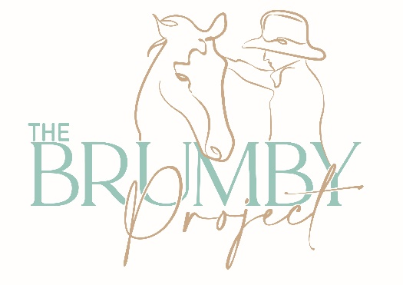

**Booking form for July 2025 Introductory Brumby Camp**

* Dates: 24 – 27th July 2024
* Cost: $880 pp + gst
* BYO camping setup. Water, shower, toilet and electricity available.
* Dinners and morning teas catered. BYO breakfast and lunches.
* If you have a roller/long reins, stiff rope halter and rope, horsemanship stick then please bring these along. If you don’t then these can be supplied! Please note that you must byo gear if bringing your own horse.

This clinic is designed to provide participants with an introduction to TBP Camps and methods. Each participant will have the opportunity to work with a brumby under guidance and to understand the fundamental horsemanship skills and techniques covered in the first few days of Brumby Camps. Horses that are more advanced will be used to demonstrate other techniques and methods and allow participants to get comfortable with their ground-handling skills. A slower-paced and supportive environment, without the pressure of getting your horse to a certain level in order to take him/her home.

Please feel free to get in touch with any further questions.

|  |  |
| --- | --- |
| **Participant Details** | |
| *First name / Name* |  |
| *Address/where are you travelling from* |  |
| *Email address and mobile phone number* |  |
| *Medical History/important medical details*  *(allergies/medications). Special dietary requirements?* |  |
| *Rider Level*  *Please detail your horse experience/aims for this camp.* |  |
| *Are you bringing your own brumby for the camp?* |  |
| *Do you plan on taking a brumby home?*  *Note that brumbies are not included in the price for the Introductory Camp, however can be arranged at the conclusion of the camp. There will not be one horse per person (as with the full-length camps).* |  |
| *Emergency Contact details/ next of kin* |  |
| *Do you have any special requirements/requests for this camp?* |  |